

In this lesson we will talk about how to hide and show and toggle components in React Native It is a very basic requirement of many projects you must have see many mobile application or web application we make small UI or component show or hide or toggle. How do we do this in React native we will see it. One thing we could ask we was studying useEffect hook with lifecycle methods. Are they completed one lifecycle remains which is unmount that whenever we unmount a component then how we can useEffect Teacher will tell us in next lesson because before using unmount lifecycle we should know that what does it mean to unmount and how to unmount a component All right in this part when we will do show/hide then it is by default unmounting By unmounting we mean remove the component from the UI or hide it. So in this lesson we will see unmounting part and in next lesson we will see unmounting life cycle method So first we need to make a component. We will take button or state and as we click on the button so we will do normal show and hide and then later how to toggle it we will see it so these three things are very important

If your component is visible then how to hide it or vice versa. Which people call toggle. So this is a common question which are often asked we will cover it all. So first off al we start with code and we make simply a component in the same file. We name it user and our component will look as shown below

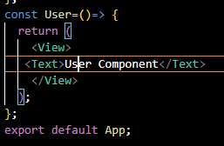

2:05

We add some style in it that is make the font size 30 and color as green Now we will use it inside our App component Now our code will look like below

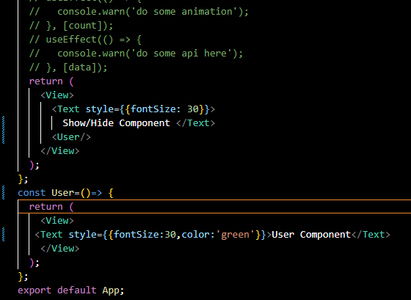

Now our output will look like below



Now we just simply a button Now you can take it above or below the component it does not matter give the title Hide component and add onPress on button what to do in it will be told by the teacher but first of all we take a state show and its update method is setShow and its default value is true

Now in onPress pass the arrow function and call setShow and pass it false now as we do setShow(false). By default show value is true and we make it false and the component will be hidden For now if we click on Hide component button then nothing happens

Now our code will look below

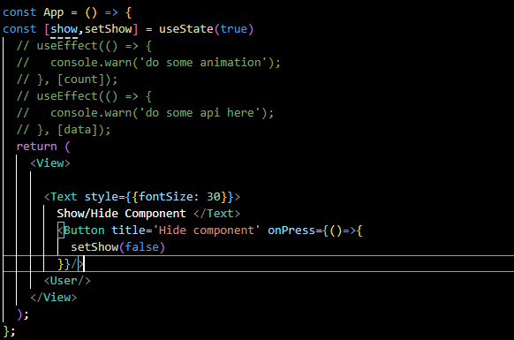

Now our output will look like below

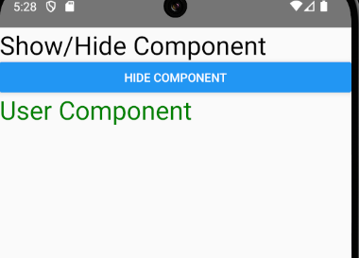

But if we place User component in between JSX brackets add a condition(with the help of conditional ) that if our show variable is equal to true then component should be shown or else null should be there means nothing

Now our code will look like below

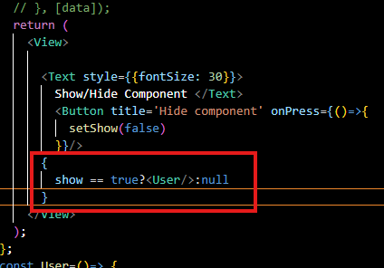

Now you can see our JSX bracket code(who knows) as marked above

Now after reloading the app as we click on Hide Component then you cannot see user component is hidden now as shown below

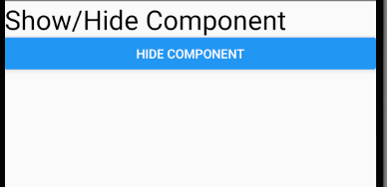

It is because after click of the button the show value becomes false

Show === true or show is same in conditional expression

And now suppose we give false as a by default value to show

Then you will not see the component as User is by default hidden



And we modify onPress and this time pass set time true so it become visible after button press

Now if we click on Hide component button then the User component will be visible as shown below

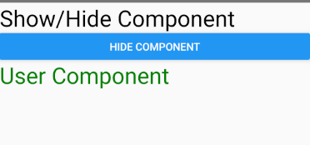

We make two button one name is Show Component and second button is Hide Component and in Show component button onPress callback make the setShow as true so that the User Component will become visible and in Hide component button onPress callback make the setShow as false so that the User Component will become visible

Now our code will look like below

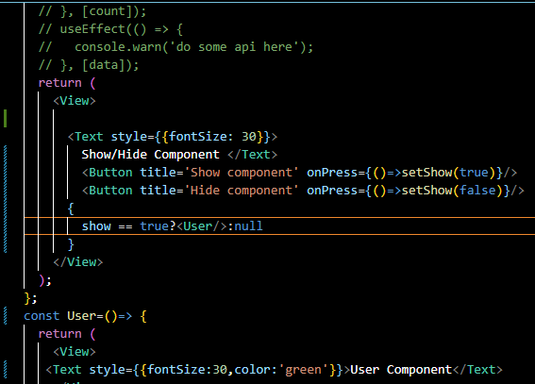

Now by default our User component is visible Our ui will look like below

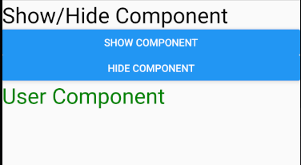

If we click on Hide button then User component will be hidden and our UI will look like below

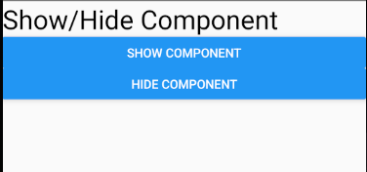

Now if we click on Show component button now our user component will be visible and look like below



But if we want to do show and hide with only one button then it is very easy Remove both the button and make the same button and name it toggle Component

**Discovery:-**

Best way to toggle is by using not operator with Boolean variable.(Brilliant idea by the teacher)

5:55